**Topic 4: Managed Futures**



Managed Futures Industry Development and Regulation

* Actively managed
* Commodity Futures Trading
* Commission (CFTC)
* Commodity pool operators (CPOs)
* Commodity Trading Advisors
* (CTAs)
* Funds
* Futures commission merchants
* (FCMs)
* Futures fund
* Introducing brokers (IBs)
* Managed accounts
* National Futures Association (NFA)

Discuss the historical foundation and development of the managed futures markets and industry, the role of regulatory agencies and industry associations, and describe the characteristics and functions of industry organizations.

* Chicago Board of Trade was founded 1848.
* 2008, there were 902 entities registered with the US Government as Commodity Trading Advisors (CTAs)
* Future funds vs. Managed futures accounts. Managed Accounts are simpler, less costly, and require a higher minimum investment.

CFTC:

The Commodity Futures Trading Commission (CFTC) is an independent agency of the United States government. The Commodity Exchange Act (CEA), prohibits fraudulent conduct in the trading of futures contracts. In 1974, Congress amended the Act to create a more comprehensive regulatory framework for the trading of futures contracts and created the Commodity Futures Trading Commission, replacing the Commodity Exchange Authority. The stated mission of the CFTC is to protect market users and the public from fraud, manipulation, and abusive practices related to the sale of commodity and financial futures and options, and to foster open, competitive, and financially sound futures and option markets.

NFA:

Based in Chicago. The National Futures Association (NFA) is an independent self-regulatory organization and watchdog of the commodities and futures industry in the United States. The NFA oversees and protects investors from fraudulent commodities and futures activities. The NFA also provides mediation and arbitration for resolving consumer complaints. NFA is headquartered in Chicago, IL and also maintains an office in New York City.

Managed Futures Strategies

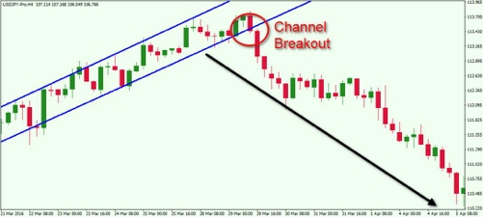

* Break-out strategies
* Channel breakout
* Countertrend
* Degradation
* Discretionary strategies
* Fundamental analysis
* “Look back”
* Moving average
* Non-trend following strategies
* Overfitting
* Systematic strategies
* Relative Strength Index (RSI)
* Relative value strategies
* Technical analysis
* Trend following strategies

**1. Describe and apply, to a specific futures market, the three groups of systematic trading strategies that are typically employed by CTAs:**

1. Trend Following

This is the dominant style employed by CTAs.

1. Non-trend following

Various statistical measures like RSI and price oscillation.

1. Relative Value Looks to capture inefficient short-term price divergences between two correlated futures contracts.

**2. Discuss the main issues surrounding diversification across trading styles in the context of managed futures.**

1. Long/Short
2. Time Frames
3. Trading Styles

Risk and Performance Measurement in Managed Futures Strategies

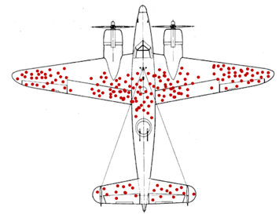Note: “Survivorship Bias”

* Backfill bias
* Capital at Risk (CaR)
* Initial margin
* Look-back bias
* Margin to equity ratio
* Maximum drawdown
* Momentum
* Selection bias
* Stop loss rules
* Stress test
* Survivorship bias
* Value at Risk (VaR)

**1. Describe, calculate and interpret the results arising from the main tools available for risk management in the managed futures space.**

1. Margin to Equity Ratio

* The amount of initial margin that must be in an account at a broker in order to trade a specific set of futures contracts, expressed as a percentage of the net asset value of the investment account.
* A high margin to equity indicates highly levered trading OR diversified across several different exchanges.

1. Capital at Risk (CaR)

* Capital at Risk represents the total loss that would be incurred should each position hit its stop loss price level on that day.
* So, there is an issue if order gets executed with the Stop Loss also exposure to Agriculture because it jumps so much.
* It assumes that each stop loss is set at 1% of the notional value of each contract.
* CaR often overstates a portfolio’s risk since it does not account for the possibility that a portfolio may hold both long and short futures positions.

1. Value at Risk (VaR)

Method of measuring potential loss in an investment portfolio, given a particular holding period, with no changes to the portfolio during the holding period, and at a particular confidence level.

1. Maximum Drawdown

Relative value of the last peak price to the all-time low price since the peak was reached.

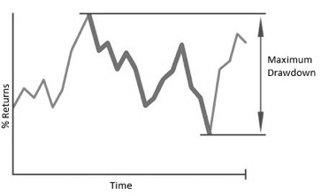Note: “Maximum Drawdown”

1. Stress Tests

Market simulation applied to a portfolio to determine how it will perform under difference market scenarios.

**2. Discuss the main findings and caveats of the research on the performance of individual trading strategies and the benefits of managed futures.**

* Selection bias- Funds may choose to report to different sources
* Look back bias – some funds don’t report. And you can include them.
* Survivorship bias – report only funds which survive. Dead funds excluded.
* Backfill bias – fill in prior history

Benchmarking and Investment Products

* Access bias Active benchmarks
* Passive benchmarks Slippage costs

1. Discuss the attributes of managed futures in terms of FIVE attributes:

ADVANTAGES OF MANAGED FUTURES -- CTAS

* liquidity: low SLIPPAGE costs b/c high liquidity
* non-directional strategy: equally likely to go long or short positions
* optionality: similar to long gamma positions (up market) and dynamic hedging (down market).
* implicit leverage: Futures market offer levered trading with no borrowed money.
* transparency: Exchange traded futures and options are continually updated

2. Explain how adding managed futures to traditional portfolios would benefit these portfolios and what the sources of these benefits are.

* Over the 1991 to 2008 period the performance of CTAs has been very competitive with traditional asset classes.

**3. Describe the three approaches to benchmarking managed futures performance. Pg 201.**

1. Index of LONG ONLY futures contracts

This is a poor choice for a benchmark because CTAs are equally likely to pursue long or short strategies in any futures market at any point in time.

1. Active Benchmarks

Active benchmarks tend to exhibit selection biases.

1. Passive Benchmarks

Passive. Works well for Trend following CTAs.

Investment Analysis in Managed Futures pg 205 Big Book



* Administrators
* Annual audit
* Due diligence
* Investment advisory agreement
* Offering document
* Redemption form
* Subscription agreement

**1. Describe the process used by investors to identify and analyze managed futures traders, including the following steps that would be common across most approaches to managed futures investments:**

* Sourcing managers

One of the best ways is through Referrals

* Qualitative analysis of managers

Firm, biographies, organization, references, goals and objectives of firm

* Quantitative analysis of managers

Composite track record

Actual track record of an individual project or fund

Pro forma or simulated track records

* Investment recommendation

General Manager Information

Pretty much the protocol that fund-of-funds goes through

* Due diligence

Review which focuses on the legal documents of an investment vehicle and back office operations of an investment firm.

* Performance monitoring

On a regular basis, each investment will be quantitatively compared on the basis of its

Do Professional $ Currency $ Managers Beat the Benchmark? Pojarliev and Levich

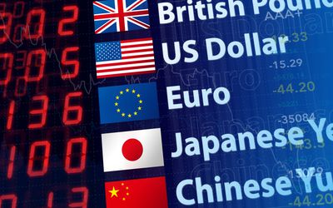

* Alpha returns
* Beta returns
* Information ratio
* Reporting biases

**1. Identify and explain each of the four style factors of $currency$ returns.**

1. Carry Factor
2. Trend Following Factor
3. Value Factor
4. Volatility Factor

**2. Explain the potential risks of each of the following trading strategies:**

1. Carry trade RISKS

* High interest rate currency with depreciate
* Low interest rate currency with appreciate

1. Trend following RISKS

* Reversals from trends
* False signals
* Excessive Trading Costs

1. Value RISKS

* Undervalued can always become MORE undervalued.
* DELAY of reversion to equilibrium.
* Structural MACRO elements could change the PPP

1. Volatility RISKS

* Being on the wrong side of volatility

**3. Explain the differences in performance for active currency managers at the index level during the 1990s and the post-2000 periods in terms of excess return and volatility.**

* Returns to Trend and Volatility were LOWER
* Returns to CARRY and VALUE were HIGHER
* Alpha generation PERSISTED

**4. Identify and explain the biases that are inherent in the professional $ currency $ manager index.**

1. Survivorship Bias

Dead Funds excluded

1. Reporting Bias

Funds only report good results

**5. Evaluate, justify, and apply the alternative information ratio as an appropriate measure of performance for individual currency managers.**

* Information Ratio is often used to calculate fees for the funds.
* By definition, the information ratio, IR, is the ratio of excess returns to their standard deviation.
* IR = return / tracking error. Like Sharpe ratio. But it is for Active Return. Instead of standard deviation – Tracking Error is used.

**6. Compare and contrast the traditional and alternative information ratios.**

* The alternative information ratio calculates the alpha as the difference between the manager’s return and the four-factor benchmark return.
* The alternative information ratio accounts for all four sources of risk and is a better risk-adjusted performance measure than the traditional information ratio.
* Chart shows that the mean and median values of the IR* are smaller than they are for the traditional IR.
* IR*< IR

**7. Interpret the positive and negative exposure to style factors.**

Studied managers. Not clear if they were true alpha generators with these four styles

1. Carry Factor Exposure

* Positive: Long high interest rate currencies
* Negative: Short high interest rate currencies

1. Trend Factor Exposure

* Positive: Momentum worked during 2001-2006
* Negative: Contrarian is going to be negative

1. Value Factor Exposure

* Positive: Long undervalued currencies
* Negative: May be indicative of carry factor emphasis

1. Volatility Factor Exposure

* Positive: Long Volatility
* Negative: Short Volatility

**8. Identify and explain the sources of alpha for active $currency$ managers.**

1. Security Selection
2. Allocation
3. Instruments